**PL/SQL programming:**

**QUESTION 1: Exercise 1: Control Structures:**

**Scenario 1:** The bank wants to apply a discount to loan interest rates for customers above 60 years old.

* + **Question:** Write a PL/SQL block that loops through all customers, checks their age, and if they are above 60, apply a 1% discount to their current loan interest rates.

**Scenario 2:** A customer can be promoted to VIP status based on their balance.

* + **Question:** Write a PL/SQL block that iterates through all customers and sets a flag IsVIP to TRUE for those with a balance over $10,000.

**Scenario 3:** The bank wants to send reminders to customers whose loans are due within the next 30 days.

* + **Question:** Write a PL/SQL block that fetches all loans due in the next 30 days and prints a reminder message for each customer.

**Scenario 1-SOLUTION:**

create database bankdb;

use bankdb;

CREATE TABLE customers (

customer_id INT PRIMARY KEY,

name VARCHAR(100),

age INT,

balance DECIMAL(10, 2),

IsVIP BOOLEAN DEFAULT FALSE

);

CREATE TABLE loans (

loan_id INT PRIMARY KEY,

customer_id INT,

interest_rate DECIMAL(5, 2),

due_date DATE,

FOREIGN KEY (customer_id) REFERENCES customers(customer_id)

);

-- Customers

INSERT INTO customers VALUES

(1, 'John', 65, 5000.00, FALSE),

(2, 'Alice', 45, 12000.00, FALSE),

(3, 'Bob', 70, 8000.00, FALSE);

-- Loans

INSERT INTO loans VALUES

(101, 1, 9.5, '2025-07-10'),

(102, 2, 8.0, '2025-06-30'),

(103, 3, 10.0, '2025-06-28');

DELIMITER $$

CREATE PROCEDURE ApplySeniorCitizenDiscount()

BEGIN

DECLARE done INT DEFAULT FALSE;

DECLARE cust_id INT;

DECLARE cur CURSOR FOR

SELECT customer_id FROM customers WHERE age > 60;

DECLARE CONTINUE HANDLER FOR NOT FOUND SET done = TRUE;

OPEN cur;

read_loop: LOOP

FETCH cur INTO cust_id; -- Get the next customer_id

IF done THEN

LEAVE read_loop; -- Exit the loop when done

END IF;

UPDATE loans

SET interest_rate = interest_rate - 1

WHERE customer_id = cust_id;

END LOOP;

CLOSE cur;

END$$

DELIMITER ;

CALL ApplySeniorCitizenDiscount();

SELECT * FROM loans;

OUTPUT:

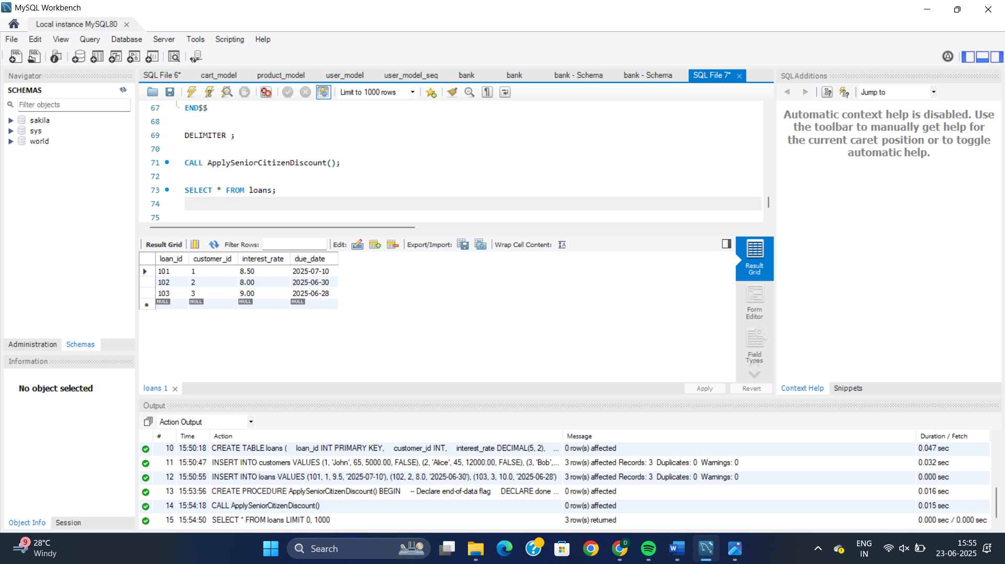

**Scenario 2-SOLUTION:**

DELIMITER $$

CREATE PROCEDURE PromoteToVIP()

BEGIN

UPDATE customers

SET IsVIP = TRUE

WHERE balance > 10000;

END$$

DELIMITER ;

CALL PromoteToVIP();

SELECT * FROM customers;

OUTPUT:

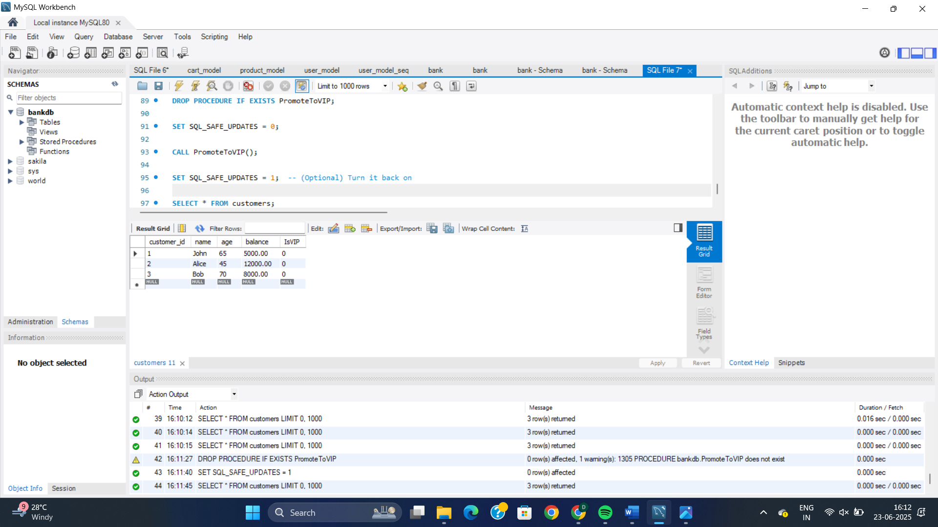

**Scenario 3-SOLUTION:**

USE bankdb;

DELIMITER $$

CREATE PROCEDURE SendLoanReminders()

BEGIN

DECLARE done INT DEFAULT FALSE;

DECLARE v_loan_id INT;

DECLARE v_customer_name VARCHAR(100);

DECLARE v_due_date DATE;

DECLARE v_amount_due DECIMAL(10,2);

DECLARE loan_cursor CURSOR FOR

SELECT

l.loan_id,

c.name,

l.due_date,

l.amount_due

FROM loans l

JOIN customers c ON l.customer_id = c.customer_id

WHERE l.due_date BETWEEN CURDATE() AND CURDATE() + INTERVAL 30 DAY;

DECLARE CONTINUE HANDLER FOR NOT FOUND SET done = TRUE;

OPEN loan_cursor;

loan_loop: LOOP

FETCH loan_cursor INTO v_loan_id, v_customer_name, v_due_date, v_amount_due;

IF done THEN

LEAVE loan_loop;

END IF;

SELECT CONCAT(

'Reminder: Dear ', v_customer_name,

', your loan (ID: ', v_loan_id,

') of amount ₹', v_amount_due,

' is due on ', v_due_date, '. Please make the payment on time.'

) AS Reminder_Message;

END LOOP;

CLOSE loan_cursor;

END$$

DELIMITER ;

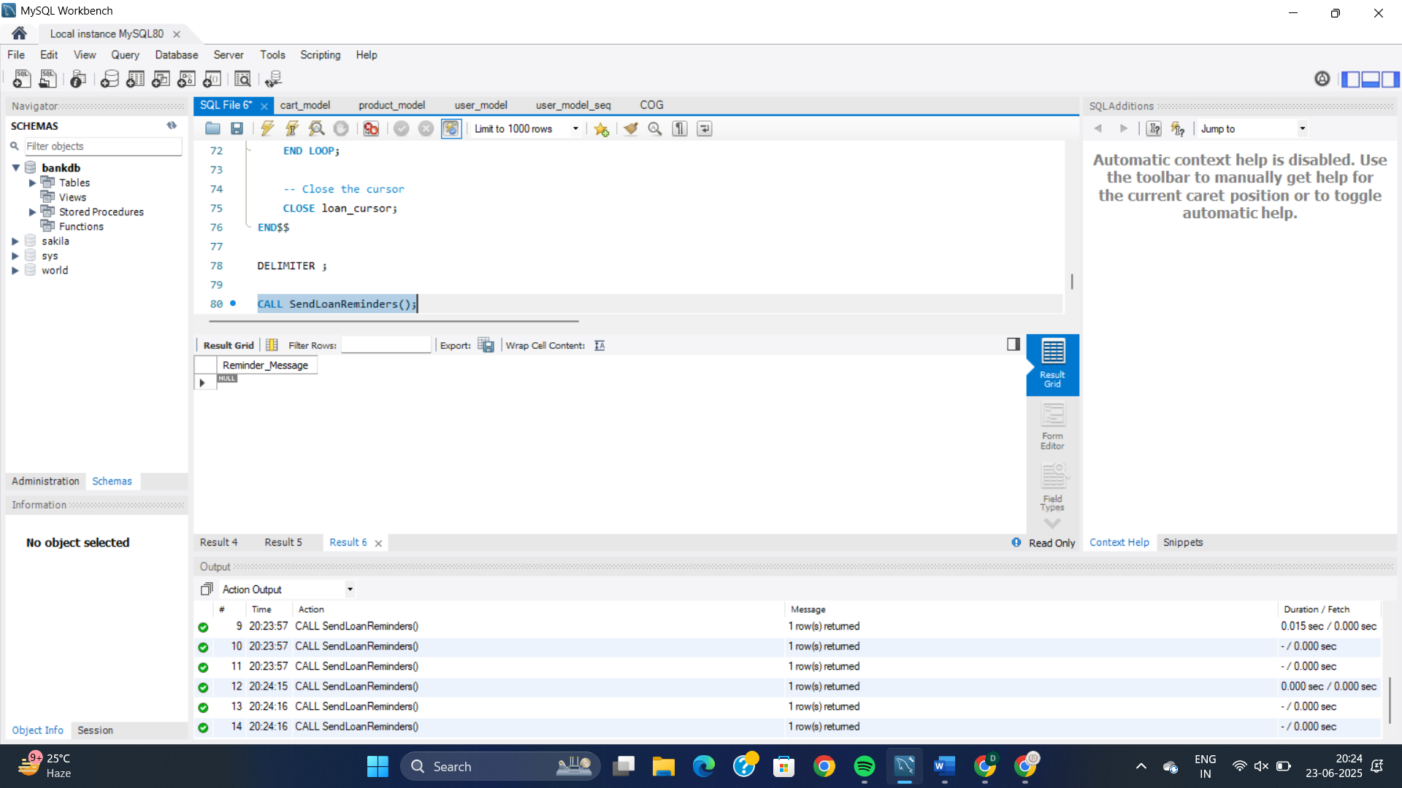

**QUESTION 2:** **Exercise 3: Stored Procedures**

**Scenario 1:** The bank needs to process monthly interest for all savings accounts.

* + **Question:** Write a stored procedure **ProcessMonthlyInterest** that calculates and updates the balance of all savings accounts by applying an interest rate of 1% to the current balance.

**Scenario 2:** The bank wants to implement a bonus scheme for employees based on their performance.

* + **Question:** Write a stored procedure **UpdateEmployeeBonus** that updates the salary of employees in a given department by adding a bonus percentage passed as a parameter.

**Scenario 3:** Customers should be able to transfer funds between their accounts.

* + **Question:** Write a stored procedure **TransferFunds** that transfers a specified amount from one account to another, checking that the source account has sufficient balance before making the transfer.

**Scenario 1:SOLUTION:**

create database interest;

use interest;

CREATE TABLE accounts (

account_id INT PRIMARY KEY,

account_type VARCHAR(20),

balance DECIMAL(10,2)

);

INSERT INTO accounts VALUES

(101, 'savings', 10000.00),

(102, 'current', 15000.00),

(103, 'savings', 20000.00);

DELIMITER $$

CREATE PROCEDURE ProcessMonthlyInterest()

BEGIN

UPDATE accounts

SET balance = balance * 1.01

WHERE account_type = 'savings';

END$$

DELIMITER ;

CALL ProcessMonthlyInterest();

SELECT * FROM accounts;

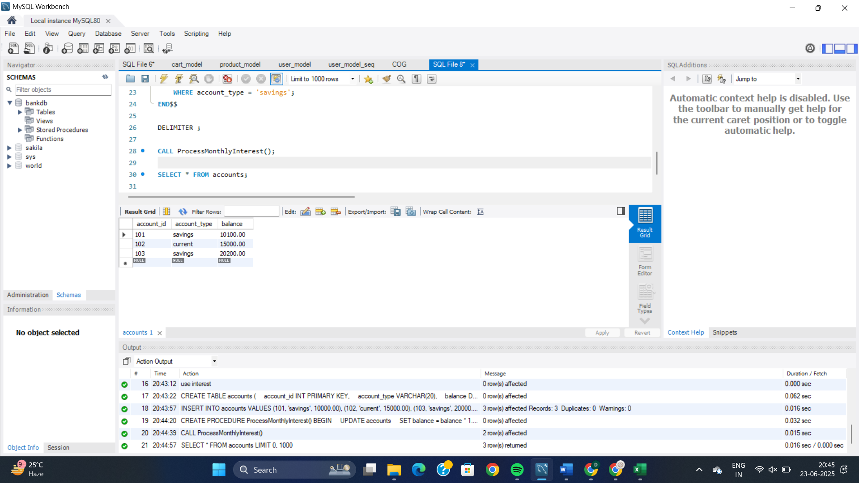

**Scenario 2: SOLUTION:**

CREATE TABLE employees (

employee_id INT PRIMARY KEY,

name VARCHAR(100),

department VARCHAR(50),

salary DECIMAL(10,2)

);

INSERT INTO employees VALUES

(1, 'Alice', 'Sales', 50000.00),

(2, 'Bob', 'IT', 60000.00),

(3, 'Charlie', 'Sales', 55000.00);

DELIMITER $$

CREATE PROCEDURE UpdateEmployeeBonus(

IN dept_name VARCHAR(50),

IN bonus_percent DECIMAL(5,2)

)

BEGIN

UPDATE employees

SET salary = salary + (salary * bonus_percent / 100)

WHERE department = dept_name;

END$$

DELIMITER ;

CALL UpdateEmployeeBonus('Sales', 10);

SELECT * FROM employees;

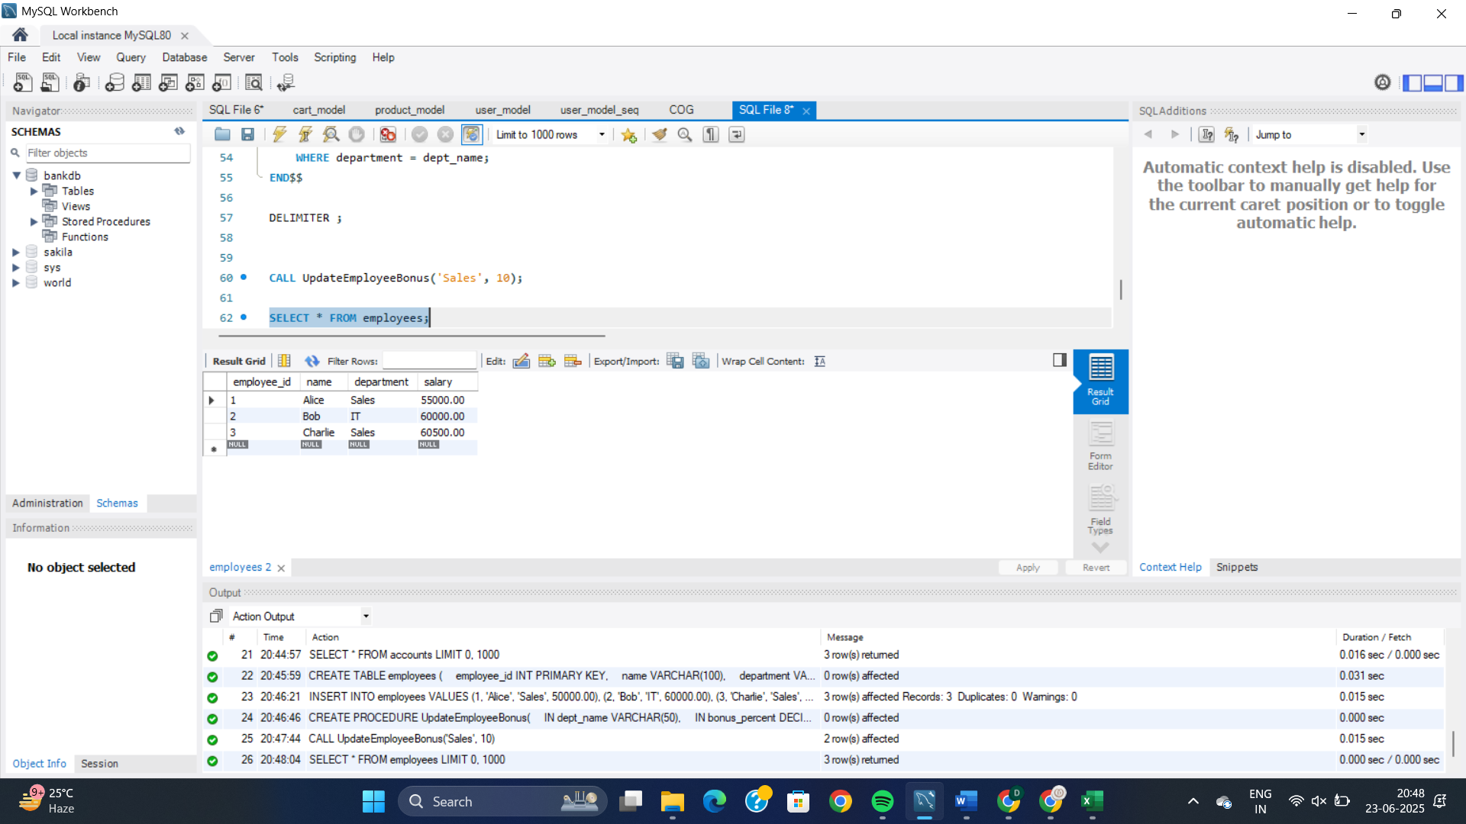

**Scenario 3: SOLUTION:**

UPDATE accounts SET balance = 10000 WHERE account_id = 101;

UPDATE accounts SET balance = 5000 WHERE account_id = 102;

DELIMITER $$

CREATE PROCEDURE TransferFunds(

IN from_account INT,

IN to_account INT,

IN transfer_amount DECIMAL(10,2)

)

BEGIN

DECLARE from_balance DECIMAL(10,2);

-- Get current balance of source account

SELECT balance INTO from_balance

FROM accounts

WHERE account_id = from_account;

-- Check if balance is enough

IF from_balance >= transfer_amount THEN

-- Deduct from source

UPDATE accounts

SET balance = balance - transfer_amount

WHERE account_id = from_account;

-- Add to target

UPDATE accounts

SET balance = balance + transfer_amount

WHERE account_id = to_account;

ELSE

SIGNAL SQLSTATE '45000'

SET MESSAGE_TEXT = 'Insufficient funds in source account.';

END IF;

END$$

DELIMITER ;

CALL TransferFunds(101, 102, 2000.00);

SELECT * FROM accounts;

